OS

Project

* 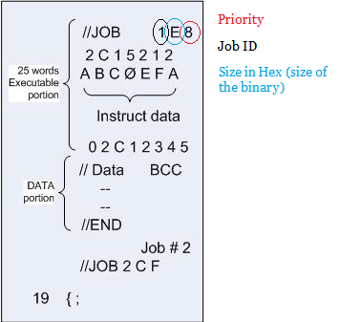
* When you read the line in the loader method
  + Insert the job id, priority and the job size in the PCB

|  |  |  |
| --- | --- | --- |
| ID | Priority | Size |
| 1 | 8 | E |
| 2 | F | C |

* The CPU is a stuct as well as the PCB